## SIMATS SCHOOL OF ENGINEERING

**SAVEETHA INSTITUTE OF MEDICAL AND TECHNICAL SCIENCES**

#### CHENNAI-602105

A CAPSTONE PROJECT REPORT

# ONLINE BUS RESERVATION SYSTEM

*Submitted in the partial fulfillment for the award of the degree of*

# BACHELOR OF ENGINEERING

## IN COMPUTER SCIENCE

**Submitted by**

**A. Sarvani Kanyaka (192211795)**

**Y. Saikiran (192211713)**

**A. Sujitha (192211834)**

**Under supervision of**

**Mr. Yuvaraj**

**JULY 2024**

# DECLARATION

I, A. Sarvani Kanyaka, Y. Saikiran, A. Sujitha students of **Bachelor of Engineering in Computer Science Engineering** at Saveetha Institute of Medical and Technical Sciences, Saveetha University, Chennai, hereby declare that the work presented in this Capstone Project Work entitled **"** **online bus reservation system "** is the outcome of my own bonafide work. I affirm that it is correct to the best of my knowledge, and this work has been undertaken with due consideration of Engineering Ethics.

A.Sarvani Kanyaka - 192211795

Y. Saikiran - 192211713

A. Sujitha - 192211834

Date:27/07/2024

Place: Saveetha School of Engineering, Thandalam.

# CERTIFICATE

This is to certify that the project entitled **“Online Bus Reservation System”** submitted by A.Sarvani Kanyaka , Y. Saikiran, A. Sujitha has been carried out under my supervision. The project has been submitted as per the requirements in the current semester of B.E Computer science engineering.

Faculty-in-charge :

**Mr. Yuvaraj**

**Table of Contents**

|  |  |
| --- | --- |
| **S.NO** | **TOPICS** |
|  | **Abstract** |
| 1 | **Introduction** |
| 2 | **Project Description** |
| 3 | **Problem Description** |
| 4 | **Tool Description** |
| 5 | **Operations** |
| 6 | **Approach / Module Description / Functionalities**  6.1 Home  6.2 Login  6.3 Register  6.4 Contact details  6.5 Payment details  6.6 Verification  6.7 Ticket Generation |
| 7 | **Implementation** |
| 8 | **Result** |
| 9 | **Conclusion** |
| 10 | **References** |

**ABSTRACT**

The transportation industry is evolving, and a robust online presence is essential for bus operators to stay competitive. Our Online Bus Reservation System offers a comprehensive solution tailored to the unique needs of bus companies, travel agencies, and passengers. This platform provides an intuitive and user-friendly interface for browsing schedules, booking tickets, and managing reservations.

Key features include customizable design templates that align with brand identity, integrated payment gateways for secure and seamless transactions, and advanced analytics tools for tracking bookings and customer behaviour. The system supports real-time seat selection and booking confirmation, ensuring a convenient and efficient experience for users.

Our Online Bus Reservation System also includes features for promoting special offers and loyalty programs, enhancing customer engagement. With a focus on responsiveness, the platform is optimized for all devices, providing a consistent and reliable experience across desktops, tablets, and smartphones.

Additionally, the system offers social media integration, enabling bus operators to leverage online marketing strategies and build a stronger community presence. High-resolution imagery and detailed descriptions of bus amenities further enhance the user experience, making it easier for customers to choose the right service.**1.** **INTRODUCTION**

Online Bus Reservation System, an ultimate solution for creating an efficient and user-friendly online presence in the transportation industry. In today's fast-paced digital world, having a robust and accessible online platform is essential for bus operators, travel agencies, and passengers. Our system is designed to simplify the booking process, manage schedules, and enhance customer satisfaction.

Our platform offers a range of customizable design templates that allow you to reflect your brand's identity, ensuring that your online presence is professional and welcoming. With integrated e-commerce capabilities, our system makes it easy to manage bookings, process payments, and provide your customers with a seamless ticketing experience.

Recognizing the importance of convenience, our Online Bus Reservation System supports real-time seat selection, booking confirmation, and high-resolution imagery of bus amenities. Our advanced analytics tools offer valuable insights into booking trends and customer preferences, enabling you to make informed decisions and optimize your services.

Furthermore, our platform ensures that your website is fully responsive, providing a consistent and engaging user experience across all devices, from desktops to smartphones. With social media integration, you can effortlessly connect with your audience, drive traffic to your site, and build a loyal customer base.

Our Online Bus Reservation System is more than just a ticketing platform; it is a comprehensive solution designed to empower transportation businesses to thrive in a competitive market. Join us and take the first step towards establishing a powerful and effective online presence that will elevate your brand and streamline your operations.

1. **PROJECT DESCRIPTION**

**Project Title:** Online Bus Reservation System Website

**Project Overview:**

The Online Bus Reservation System project aims to develop a comprehensive and user-friendly online platform specifically designed for the transportation industry. This website will serve as an essential tool for bus operators, travel agencies, and passengers to manage and streamline the booking process. By integrating advanced booking capabilities, customizable design features, and robust analytics, the platform will empower transportation businesses to enhance their online presence, increase efficiency, and improve customer satisfaction.

The system will allow passengers to easily browse bus schedules, select seats, and make reservations from any device. For operators, the platform offers tools for managing inventory, tracking bookings, and analyzing customer behavior, helping them optimize operations and drive revenue growth. Additionally, the integration of secure payment gateways and social media features will further support businesses in providing a seamless and engaging user experience, fostering a loyal customer base. The project aims to revolutionize the way bus reservations are made, making it easier and more convenient for both operators and passengers..

**Key Objectives:**

**2.1 Elegant and Customizable Design:**

- Develop User-Centric Design Templates: Create a range of user-friendly and visually appealing design templates that allow bus operators to reflect their brand's unique identity.

- High-Resolution Media Support: Ensure the platform supports high-resolution images and descriptions of bus amenities for a visually engaging user experience.

**2.2 Booking and E-commerce Integration:**

User-Friendly Booking Interface:

- Design an intuitive and straightforward interface that enables passengers to easily search for buses, select seats, and make reservations.

- Ensure the platform is accessible and responsive across all devices, including desktops, tablets, and smartphones.

Secure Payment Processing:

- Integrate secure and reliable payment gateways to facilitate seamless and safe transactions.

- Offer multiple payment options to accommodate different user preferences.

Analytics and Insights:

- Implement advanced analytics tools to track booking trends, user behavior, and website traffic.

- Provide actionable insights to help operators optimize routes, pricing, and customer service.

Social Media Integration:

- Enable seamless integration with social media platforms to enhance marketing efforts and community engagement.

- Allow users to share travel plans, promotions, and experiences through various social media channels.

Customer Engagement and Support:

- Incorporate features for customer reviews, feedback, and support to build strong relationships between operators and passengers.

- Provide tools for personalized communication and offers to enhance customer loyalty.

**2.3 Project Scope:**

Requirement Analysis:

- Conduct a detailed analysis of the needs and preferences of bus operators and passengers.

- Gather requirements through market research, surveys, and consultations with industry experts.

Design and Development:

- Create wireframes and design mockups based on gathered requirements.

- Develop the website using modern web technologies and best practices for security, performance,

and scalability.

Testing and Quality Assurance:

- Conduct comprehensive testing to ensure the website is free of bugs and performs optimally.

- Implement user testing sessions to gather feedback and make necessary adjustments.

Deployment and Launch:

- Deploy the website on a reliable hosting platform.

- Ensure a smooth launch with a marketing strategy to attract initial users.

Post-Launch Support and Maintenance:

- Provide ongoing technical support and updates to ensure the website remains up-to-date and functional.

- Gather user feedback for continuous improvement and feature enhancements.

**3. PROBLEM DESCRIPTION**

Key Problems to Address:

**3.1 Complexity of Website Creation:**

- Bus operators often lack the technical expertise required to create and maintain a professional-looking online booking system.

- There is a need for a simplified process that allows users to build and customize their booking platforms without extensive technical knowledge.

**3.2 Visual Presentation:**

- The appeal of bus services can be enhanced through high-quality visual content.

- The software must support high-resolution images and detailed descriptions, providing an informative and engaging user experience.

**3.3 Booking and E-commerce Integration:**

- Many bus companies struggle with integrating booking and e-commerce functionalities into their websites.

- The software should offer seamless booking features, including real-time seat selection, payment processing, and inventory management.

**3.4 Responsive Design:**

- With a significant number of users accessing booking systems via mobile devices, the software must ensure a responsive design that works well across all devices.

**3.5 Analytics and Insights:**

- Bus operators need access to analytics to understand booking trends and customer behavior.

- The software should include tools for tracking performance and generating insights to inform business decisions.

**3.6 Social Media Integration:**

- Effective online marketing is crucial for bus operators to reach a broader audience.

- The software should facilitate easy integration with social media platforms for marketing and engagement purposes.

**4. TOOL DESCRIPTION**

**4.1 Dashboard:**

- Central hub for managing all aspects of the booking system.

- Provides an overview of key metrics such as bookings, traffic, and customer activity.

- Quick access to various tools and settings.

**4.2 Drag-and-Drop Editor:**

- Allows users to easily customize their website layout without any coding knowledge.

- Includes pre-built sections (e.g., schedules, seat maps, service descriptions) that can be dragged and dropped into place.

- Real-time preview feature to see changes as they are made.

**4.3 Template Library:**

- A collection of professionally designed, customizable templates tailored for bus operators.

- Templates are categorized based on different styles and themes to suit various branding needs.

- Easy switching between templates with content preservation.

**4.4 Responsive Design:**

- Ensures the website looks and functions well on all devices, including desktops, tablets, and smartphones.

- Built-in tools to preview and adjust the website for different screen sizes.

**4.5 Tools and Technologies:**

- HTML/CSS: For creating the structure and styling of the website.

- JavaScript: For interactive elements and client-side logic.

- Responsive Frameworks (e.g., Bootstrap): For ensuring the website is mobile-friendly.

- Google Analytics: For tracking user behavior and performance metrics.

**4.6 Marketing and SEO Tools:**

- SEO Optimization: Tools for optimizing website content for search engines, including meta tags, keywords, and sitemaps.

- Email Marketing: Integration with email marketing services for newsletters and promotional campaigns.

- Social Media Integration: Easy sharing of services and promotions on social media platforms, with tracking of engagement metrics.

**5.OPERATIONS**

**5.1 Customizations**

- Template Selection and Customization: Users can choose and customize templates.

- Drag-and-Drop Interface: JavaScript frameworks (like React, Vue, or Angular) can be used to build a user-friendly drag-and-drop interface for layout customization.

- Real-time Preview: Implementing real-time preview using WebSocket or AJAX for live updates.

**5.2 Booking and E-commerce Integration**

Tools and Technologies:

- Payment Gateways (e.g., Stripe, PayPal): For handling transactions.

- Booking System Libraries: For managing the booking process and seat reservations.

Operations:

- Booking Management: Using a backend (Node.js, Django, or Ruby on Rails) for CRUD operations on bookings.

- Payment Processing: Integrating APIs from payment gateways to handle transactions securely.

- Reservation Management: Building backend logic to manage reservations, cancellations, and customer notifications.

**5.3 Inventory Management**

Tools and Technologies:

- Database Management (e.g., MongoDB, MySQL): For storing schedule and inventory data.

- Server-side Scripting (e.g., Node.js, Python): For handling inventory logic.

Operations:

- Seat Availability Monitoring: Implementing server-side scripts to monitor seat availability and trigger alerts for fully booked or under-booked buses.

- Automated Updates: Setting up automated systems to update seat availability in real-time.

**5.4 Customer Engagement**

Tools and Technologies:

- Email APIs (e.g., SendGrid, Mailchimp): For email marketing campaigns.

- Social Media APIs (e.g., Facebook, Twitter): For social media integration.

- Live Chat Tools (e.g., Intercom, Tawk.to): For real-time customer support.

Operations:

- Email Campaigns: Using email APIs to send booking confirmations and promotional emails.

- Social Media Integration: Utilizing social media APIs to share travel deals and updates directly from the website.

- Customer Reviews and Ratings: Implementing user feedback forms and displaying reviews using JavaScript and server-side scripting.

**5.5 Analytics and Reporting**

Tools and Technologies:

- Google Analytics: For tracking website traffic and user behavior.

- Custom Analytics Dashboards: Built using JavaScript libraries like Chart.js or D3.js.

Operations:

- Booking Analytics: Using server-side scripting to aggregate booking data and visualize it on custom dashboards.

- Customer Behavior Tracking: Integrating Google Analytics to monitor user interactions and generate insights.

- Performance Reports: Automated generation of reports on website performance, bookings, and customer engagement.

**5.6 Security and Compliance**

Tools and Technologies:

- SSL Certificates: For secure data transmission.

- Data Protection Tools: For ensuring compliance with regulations like GDPR.

Operations:

* User Authentication: Implementing secure login systems using OAuth or JWT.
* Data Encryption: Using HTTPS and encrypting sensitive data in the database.
* Compliance Monitoring: Regularly auditing the website for compliance with data protection regulations.

**6. Approach / Module Description / Functionalities**

* Home: We can give the home page which redirects to Seller or Buyer.
* Login: Here it appears username and password and if not register, we can register.
* Register: We can newly register by username and password.
* Contact us: This is the last and ending step and we can get the email, details and phone number.
* Payment: We can select what method of transaction we want by EMI or any Card or Online payments.
* Verification: verifying all the process
* Ticket Generation: if payment is done ticket will be generated automatically.

**7.IMPLEMENTATION**

**Home page**

<!DOCTYPE html>

<html lang="en">

<head>

<meta charset="UTF-8">

<title>Home - Bus Reservation System</title>

<link rel="stylesheet" href="styles.css">

</head>

<body>

<header>

<img src="C:\Users\Sarvani\Desktop\logo.png" alt="Bus Reservation System Logo">

</header>

<h1>Welcome to the Bus Reservation System</h1>

<nav>

<a href="register.html">Register</a> |

<a href="login.html">Login</a> |

<a href="contact.html">Contact Us</a>

</nav>

<div id="main-content">

<img src="C:\Users\Sarvani\Desktop\bus.png" alt="Bus Image">

<p>Explore our services and book your trip now!</p>

</div>

</body>

</html>

<a href="C:\Users\Sarvani\Desktop\ip project\b.html">next</a>

**Login page**

<!DOCTYPE html>

<html lang="en">

<head>

<meta charset="UTF-8">

<title>Login - Bus Reservation System</title>

<link rel="stylesheet" href="styles.css">

</head>

<body>

<header>

<img src="C:\Users\Sarvani\Desktop\login.png" alt="Bus Reservation System Logo">

</header>

<h1>Login</h1>

<form action="/login" method="POST">

<label for="email">Email:</label>

<input type="email" id="email" name="email" required>

<label for="password">Password:</label>

<input type="password" id="password" name="password" required>

<button type="submit">Login</button>

</form>

</body>

</html>

<a href="C:\Users\Sarvani\Desktop\ip project\c.html">next</a>

**Reservation form**

<!DOCTYPE html>

<html lang="en">

<head>

<meta charset="UTF-8">

<title>Register - Bus Reservation System</title>

<link rel="stylesheet" href="styles.css">

</head>

<body>

<header>

<img src="C:\Users\Sarvani\Desktop\reservation.jpg" alt="Bus Reservation System Logo">

</header>

<h1>Register</h1>

<form action="/register" method="POST">

<label for="name">Name:</label>

<input type="text" id="name" name="name" required>

<label for="email">Email:</label>

<input type="email" id="email" name="email" required>

<label for="password">Password:</label>

<input type="password" id="password" name="password" required>

<button type="submit">Register</button>

</form>

</body>

</html>

<a href="C:\Users\Sarvani\Desktop\ip project\d.html">next</a>

**Contact details**

<!DOCTYPE html>

<html lang="en">

<head>

<meta charset="UTF-8">

<title>Contact Us - Bus Reservation System</title>

<link rel="stylesheet" href="styles.css">

</head>

<body>

<header>

<img src="C:\Users\Sarvani\Desktop\contact.png" alt="Bus Reservation System Logo">

</header>

<h1>Contact Us</h1>

<form action="/contact" method="POST">

<label for="name">Name:</label>

<input type="text" id="name" name="name" required>

<label for="email">Email:</label>

<input type="email" id="email" name="email" required>

<label for="message">Message:</label>

<textarea id="message" name="message" required></textarea>

<button type="submit">Send Message</button>

</form>

</body>

</html>

<a href="C:\Users\Sarvani\Desktop\ip project\e.html">next</a>

**Payment details**

P<!DOCTYPE html>

<html lang="en">

<head>

<meta charset="UTF-8">

<title>Payment - Bus Reservation System</title>

<link rel="stylesheet" href="styles.css">

</head>

<body>

<header>

<img src="C:\Users\Sarvani\Desktop\payment.jpeg" alt="Bus Reservation System Logo">

</header>

<h1>Payment Details</h1>

<form action="/payment" method="POST">

<label for="cardNumber">Card Number:</label>

<input type="text" id="cardNumber" name="cardNumber" required>

<label for="expiryDate">Expiry Date:</label>

<input type="text" id="expiryDate" name="expiryDate" placeholder="MM/YY" required>

<label for="cvv">CVV:</label>

<input type="text" id="cvv" name="cvv" required>

<button type="submit">Pay Now</button>

</form>

</body>

</html>

<a href="C:\Users\Sarvani\Desktop\ip project\f.html">next</a>

**Verification**

<!DOCTYPE html>

<html lang="en">

<head>

<meta charset="UTF-8">

<title>Verification - Bus Reservation System</title>

<link rel="stylesheet" href="styles.css">

</head>

<body>

<header>

<img src="C:\Users\Sarvani\Desktop\verfication.jpg" alt="Bus Reservation System Logo">

</header>

<h1>Verification</h1>

<form action="/verify" method="POST">

<label for="verificationCode">Verification Code:</label>

<input type="text" id="verificationCode" name="verificationCode" required>

<button type="submit">Verify</button>

</form>

</body>

</html>

<a href="C:\Users\Sarvani\Desktop\ip project\g.html">next</a>

**Booked ticket**

<!DOCTYPE html>

<html lang="en">

<head>

<meta charset="UTF-8">

<title>Your Ticket - Bus Reservation System</title>

<link rel="stylesheet" href="styles.css">

</head>

<body>

<header>

<img src="C:\Users\Sarvani\Desktop\booked.jpeg" alt="Bus Reservation System Logo">

</header>

<h1>Ticket Confirmation</h1>

<div id="ticket-details">

<img src="images/ticket.png" alt="Ticket Image">

<p><strong>Route:</strong> City A - City B</p>

<p><strong>Departure Time:</strong> 10:00 AM</p>

<p><strong>Seat Number:</strong> 12</p>

<p><strong>Passenger:</strong> John Doe</p>

<p><strong>Ticket Number:</strong> ABC123XYZ</p>

</div>

<button onclick="window.print()">Print Ticket</button>

</body>

</html>

**8.Result**

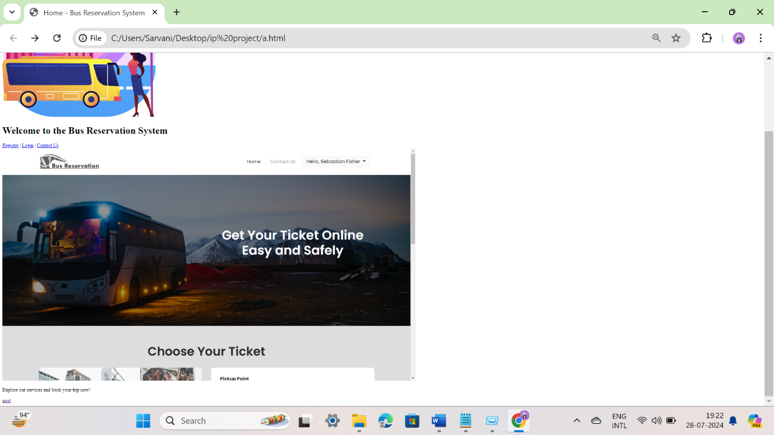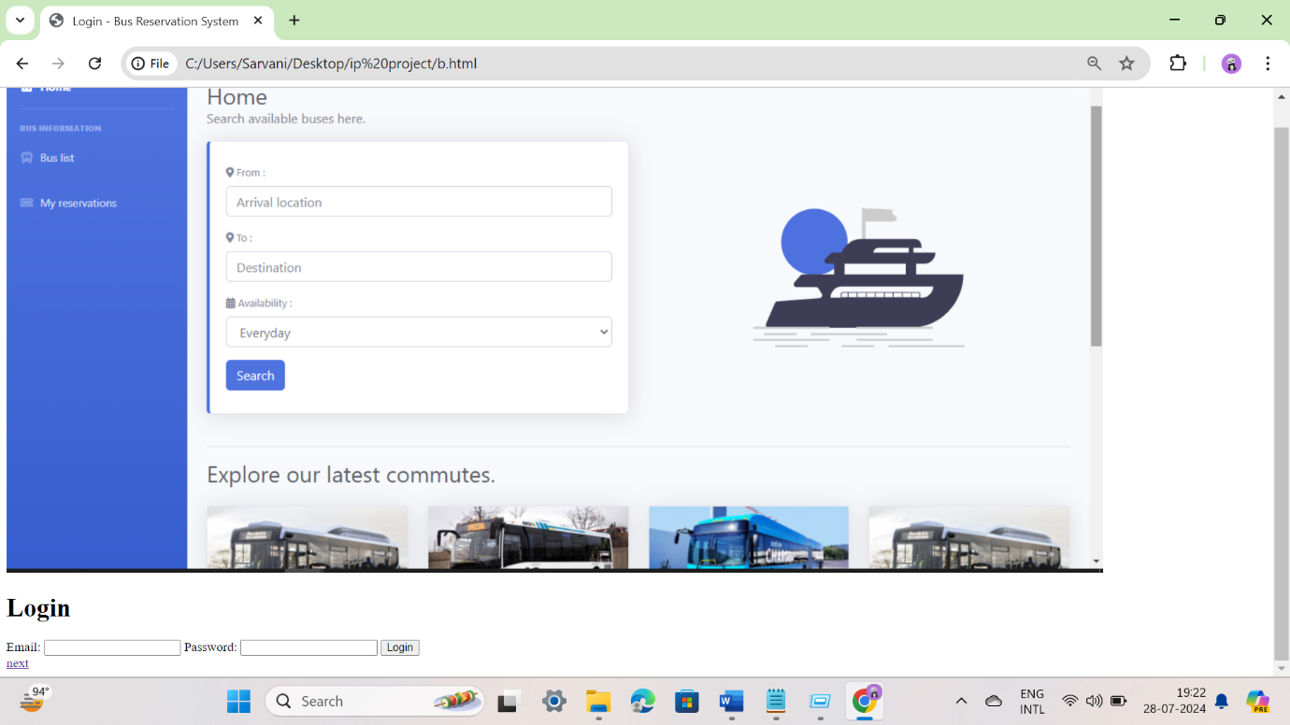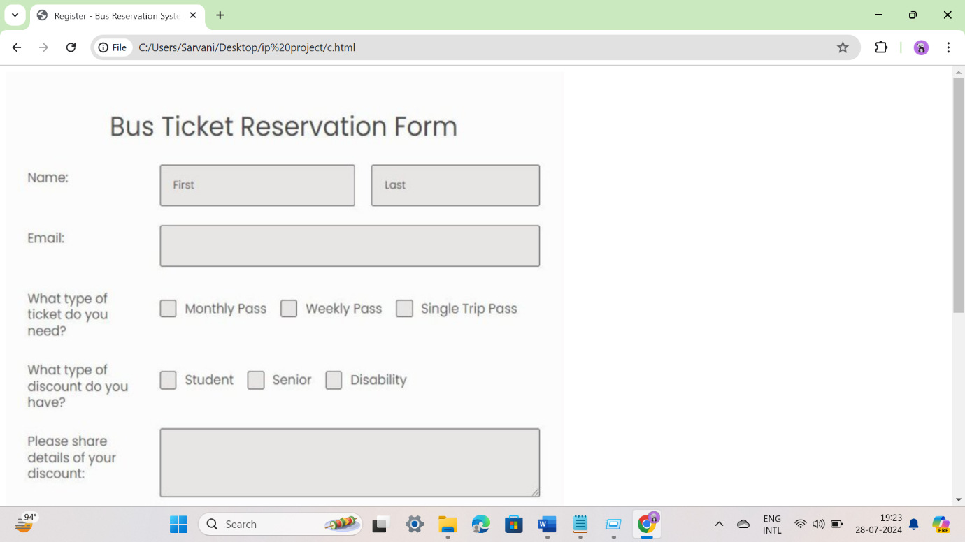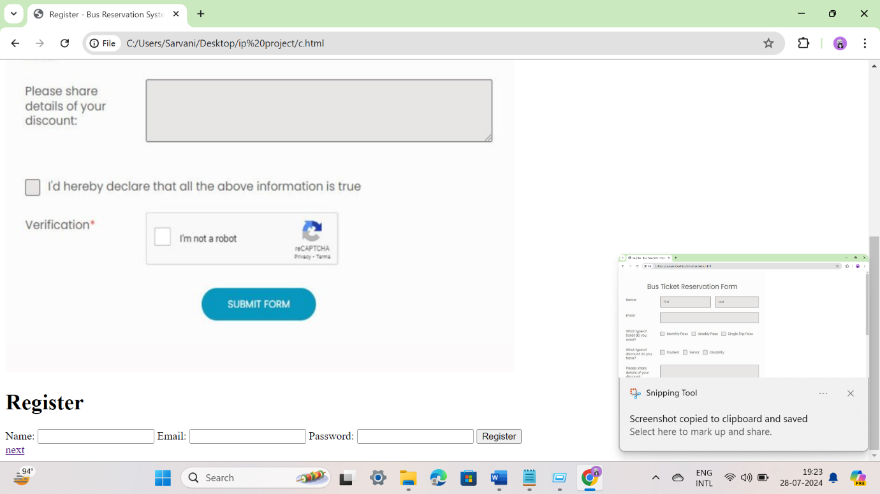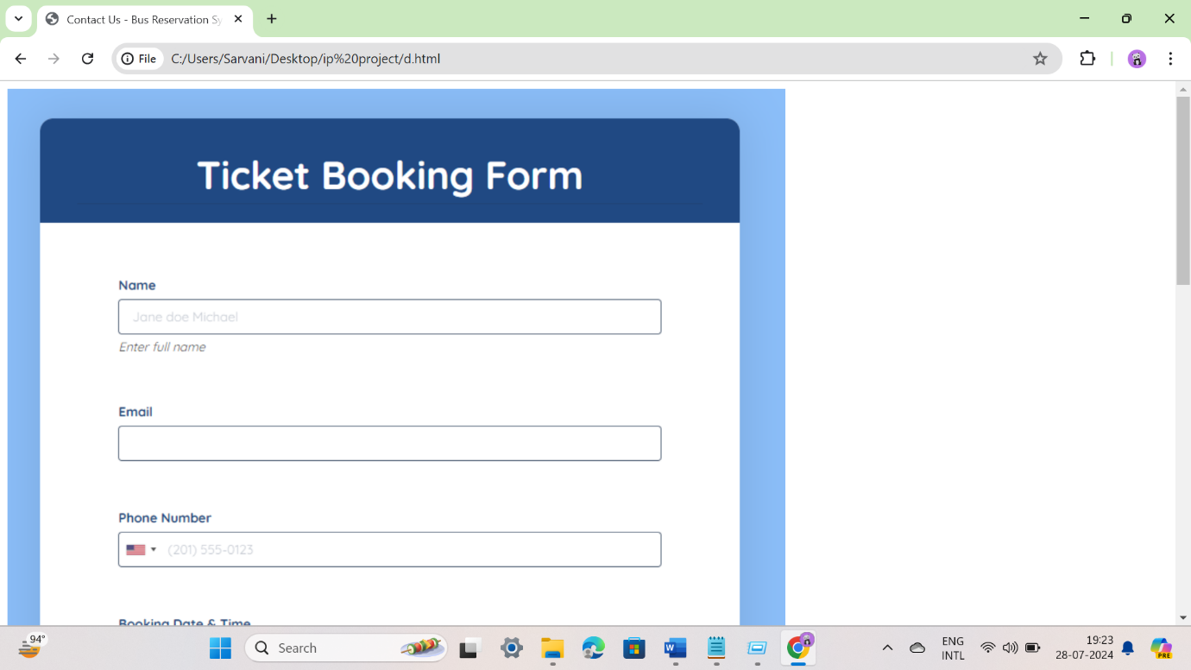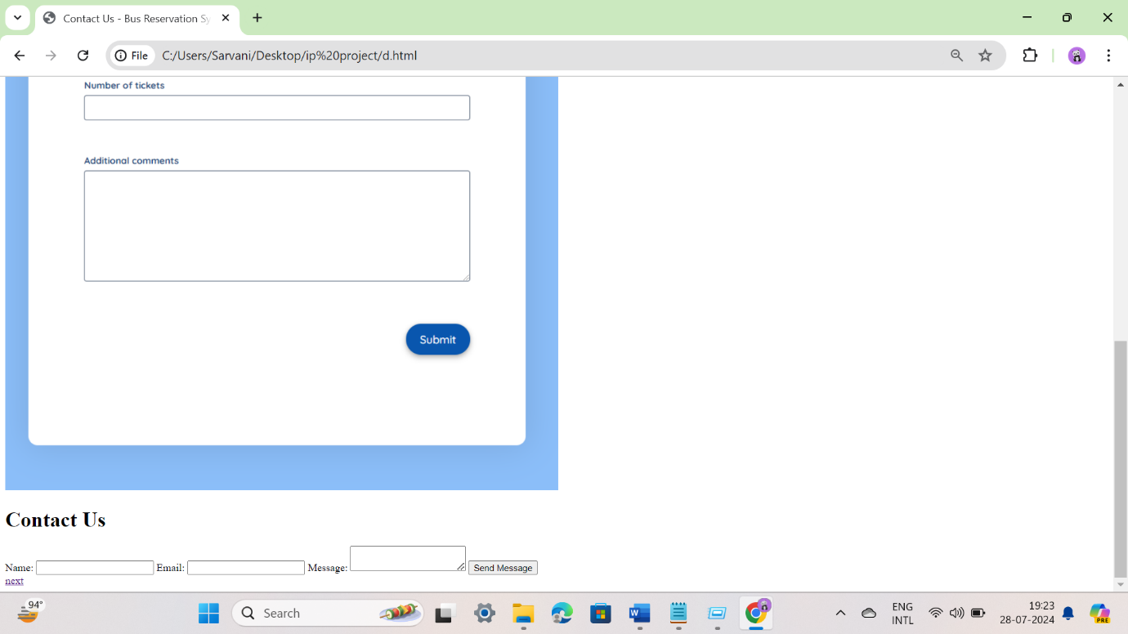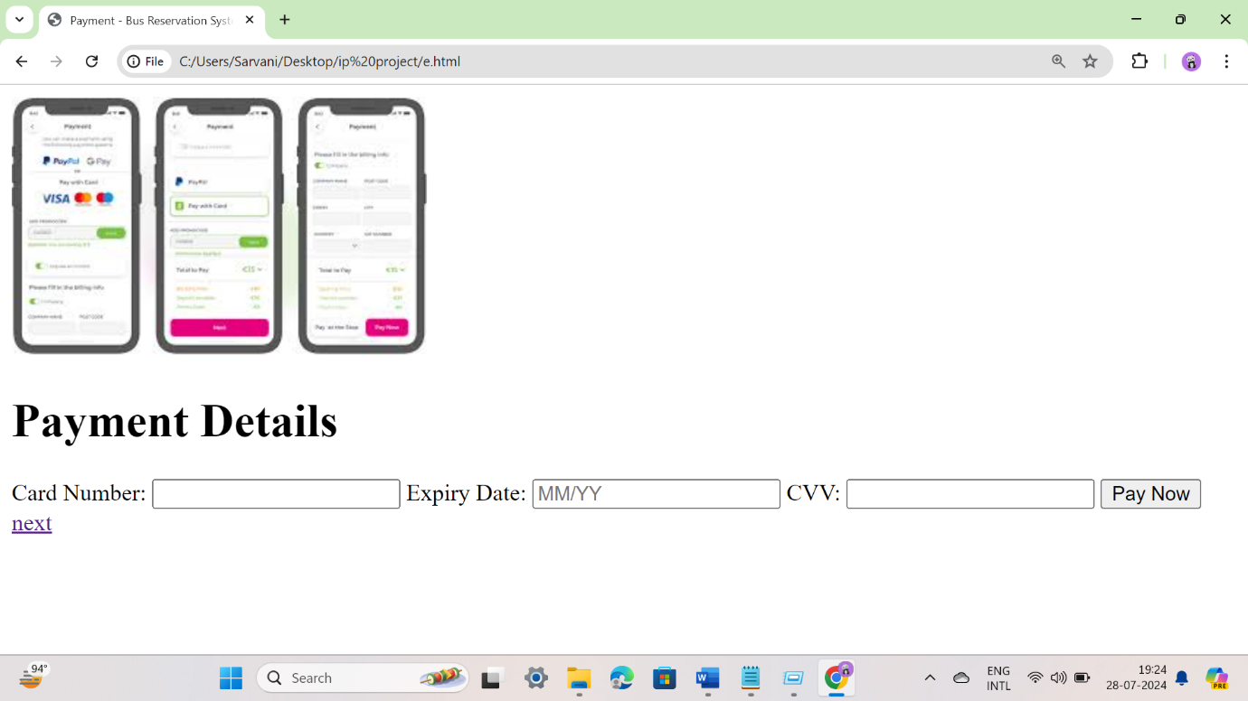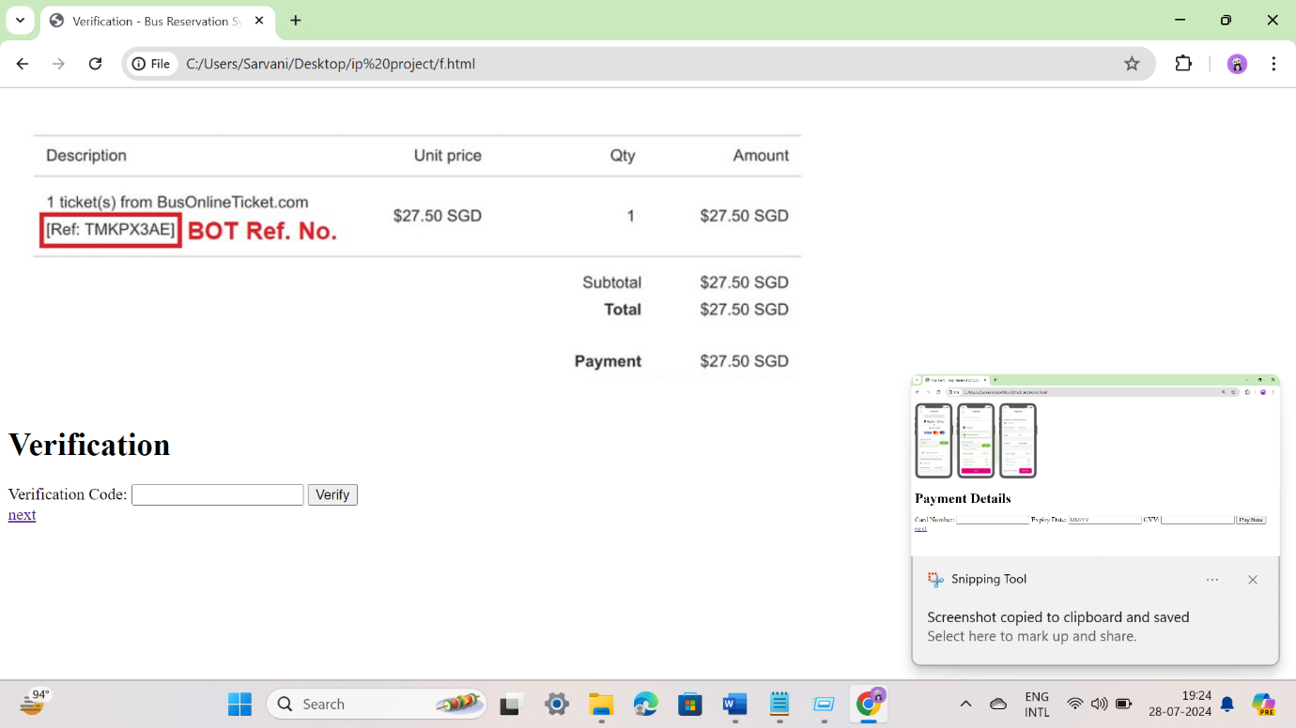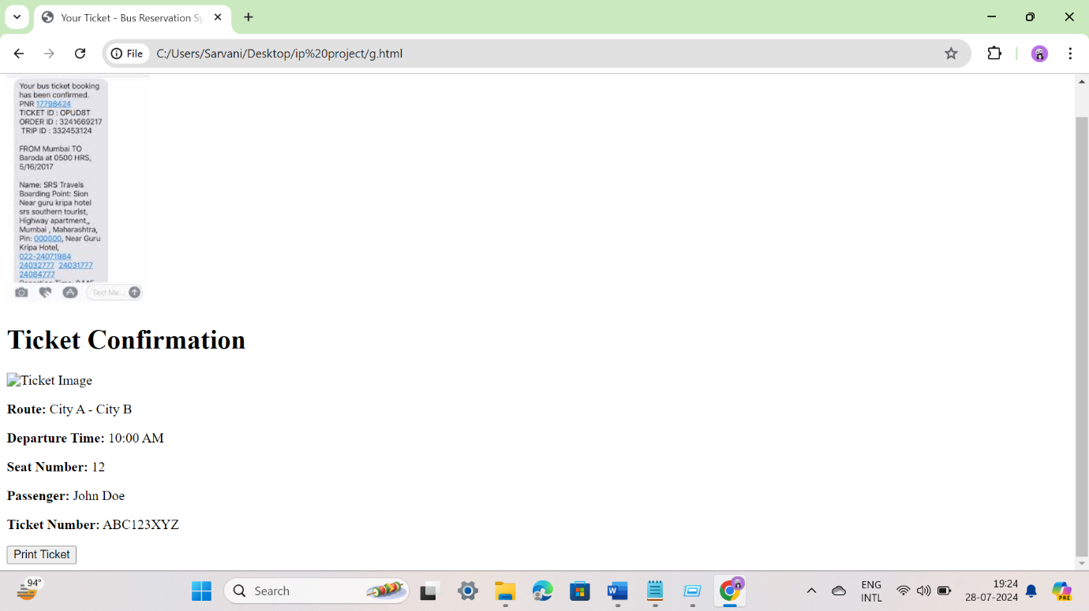

**9.CONCLUSION**

The Online Bus Reservation System project effectively addresses the critical needs of the transportation industry by providing an intuitive, customizable, and comprehensive platform. This system empowers bus operators and travel agencies to establish a strong online presence, streamline the booking process, manage their inventory efficiently, and engage with passengers effectively. Through seamless booking and e-commerce integration, the platform facilitates smooth transactions and enhances customer satisfaction. With a user-friendly interface, responsive design, and powerful analytics tools, the Online Bus Reservation System ensures that bus operators can thrive in the competitive digital landscape, providing a reliable and convenient service to their customers.

**10.REFERENCES**

1. [MDN](https://developer.mozilla.org/) [Web](https://developer.mozilla.org/) [Docs](https://developer.mozilla.org/)
2. [W3Schools](https://www.w3schools.com/) 3. [Bootstrap](https://getbootstrap.com/)
3. [CSS](https://css-tricks.com/) [Tricks](https://css-tricks.com/)
4. *GeeksforGeeks*